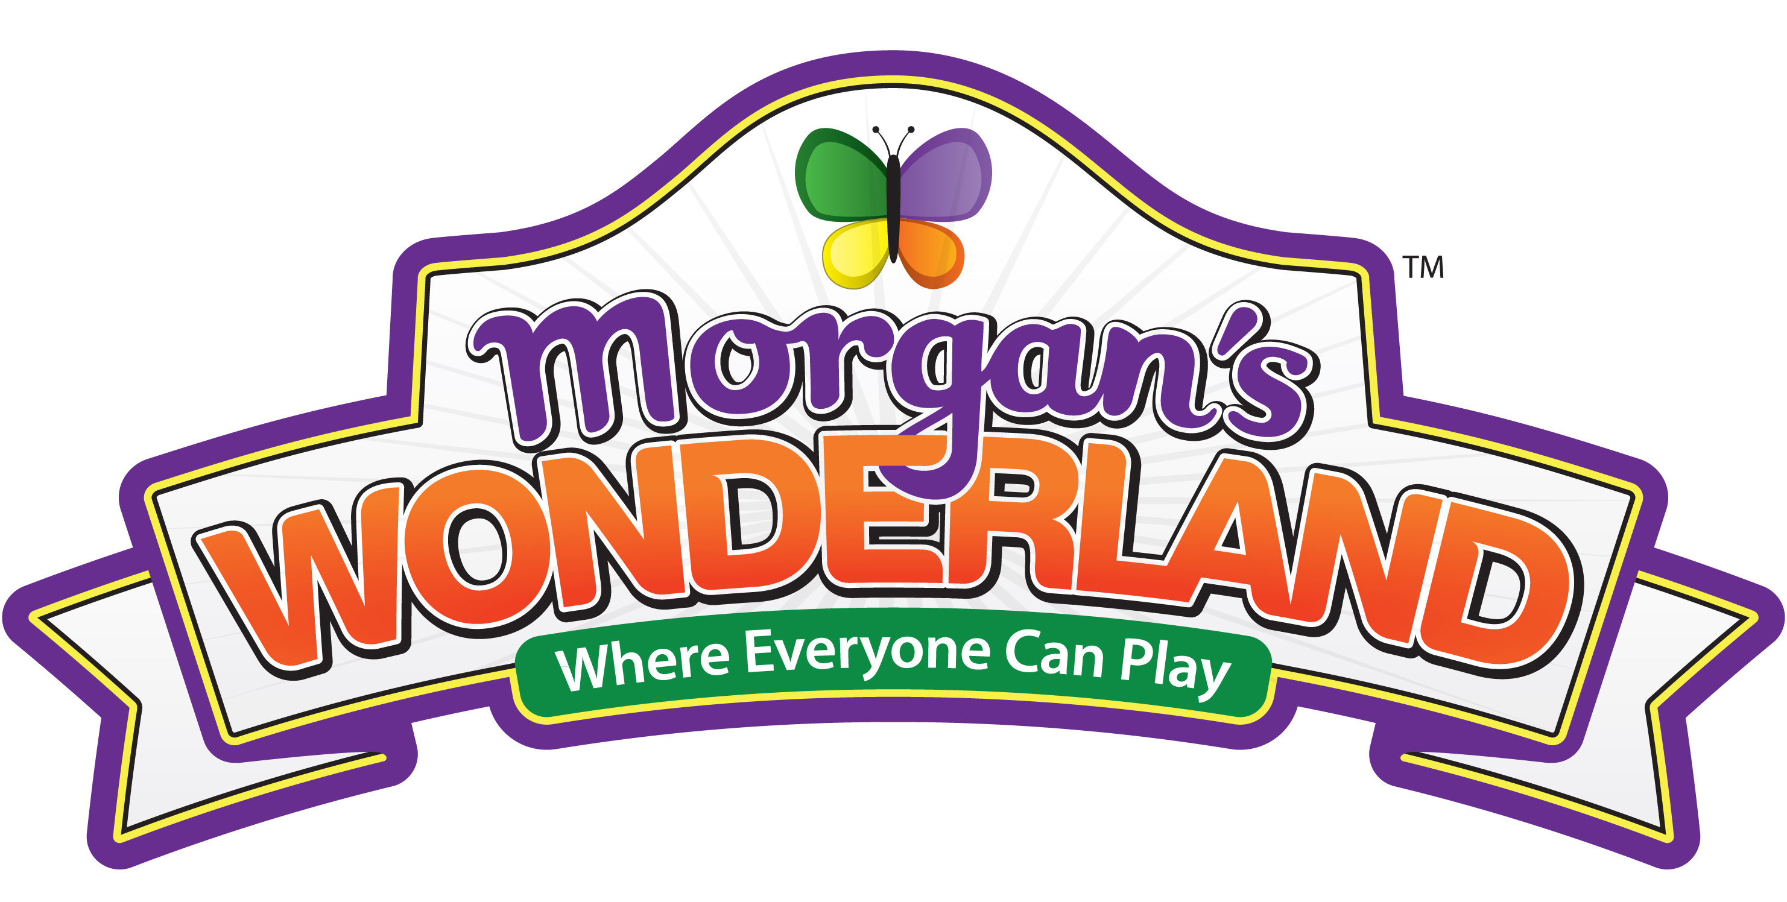
For More Information: Bob McCullough, APR, (210) 495-5888 or bmccullough@MorgansWonderland.com
April 1, 2011
Morgan’s Wonderland in Line for Two Prestigious National Honors
SAN ANTONIO – The 5th Annual Disability Matters Awards Banquet and Conference will bestow its 2011 Small Business Award upon Morgan’s Wonderland in ceremonies Wednesday, April 6, in San Jose, Calif.
Gordon Hartman, founder of The Gordon Hartman Family Foundation, will accept the award on behalf of Morgan’s Wonderland, the world’s first ultra-accessible family fun park designed with special-needs individuals of all ages in mind. He also will address the conference and describe the non-profit park’s development and growth as well as its focus on inclusion.
In addition, Morgan’s Wonderland has been named a finalist in the Public Relations Society of America (PRSA) 2011 Silver Anvil Awards competition, which recognizes excellence in communications campaigns. Silver Anvil winners will be announced at a banquet Thursday, June 9, in New York City.
The Disability Matters Awards “represent businesses that serve as role models for their peers in corporate America, the U. S. federal government and small business alike, particularly their initiatives to recruit, provide support and market to the disability community, now the largest and fastest-growing minority segment in the world,” said Nadine Vogel, founder of the Disability Matters Awards co-hosted by Cisco Corp., and Northrop Grumman Corp.
“As the mother of two children with special needs, it is so personally gratifying to see the incredible commitment of our honorees to the full inclusion of people with disabilities and their families in so many aspects of their organizations. Their passion and dedication to high standards for this important work inspires employees and customers alike.”
Hartman said the PRSA Silver Anvil recognition constitutes a total team effort. “To offer free admission to Morgan’s Wonderland to anyone with a special need, we have to operate on a tight budget,” he said. “Thus, everyone on the Morgan’s Wonderland team has pitched in to spread the word about our unique park. Thanks largely to energetic social-media efforts, our lively Website, growing numbers of special events and generous news media coverage, we were able to attract more than 100,000 guests last year during our inaugural season from 47 states and 13 other countries.”
Morgan’s Wonderland opened March 3, 2010, and celebrated its grand opening April 10, 2010. Completely wheelchair-accessible, it features more than 25 elements and attractions including rides, playgrounds, gardens, an eight-acre fishing lake, 18,000-square-foot special-event center, 575-seat amphitheater, picnic area and rest areas throughout the park.
In 2007, The Gordon Hartman Family Foundation was instrumental in the creation of SOAR (Sports Outdoor And Recreation), a non-profit organization to raise funds for building Morgan’s Wonderland. Construction on the $34 million park began in spring 2009.
Morgan’s Wonderland is part of a larger 106-acre sports venue to encourage inclusive recreation whereby individuals of all abilities can play side-by-side. The next-door STAR (South Texas Area Regional) Soccer Complex offers 13 lighted soccer fields for tournaments, instructional clinics and special events. Proceeds from STAR Soccer go to support the operation and maintenance of Morgan’s Wonderland.
Morgan’s Wonderland is located in Northeast San Antonio at the intersection of Wurzbach Parkway and Thousand Oaks Drive. For more information, visit www.MorgansWonderland.com, or call either (210) 495-5888 or toll-free (877) 495-5888.
. −30−

